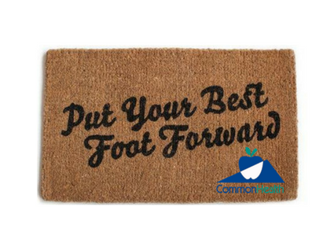
Put Your Best Foot Forward
Our poor, overworked feet. We mistreat them terribly -- standing on them for hours; walking on hard, unyielding surfaces; and cramming them into shoes that may be fashionable but are often far from comfortable. It's no wonder that 3 out of 4 adults eventually suffer from foot problems.
Relieve and prevent foot problems - change how you treat your feet!
All about Feet: Your feet really are quite awesome…feet are perfectly designed to give years of service -- if you treat them right. Each foot has 26 bones. Thirty-three joints make the feet flexible, and 19 muscles control movement of foot parts. Tendons stretch tautly between muscles and bones, moving parts of the feet as the muscles contract. Two arches in the midfoot and forefoot, constructed like small bridges, support each foot and provide a springy, elastic structure to absorb shock. Numerous nerve endings in the feet make them sensitive. Each has 250,000 sweat glands. Over 100 ligaments hold the structure together.

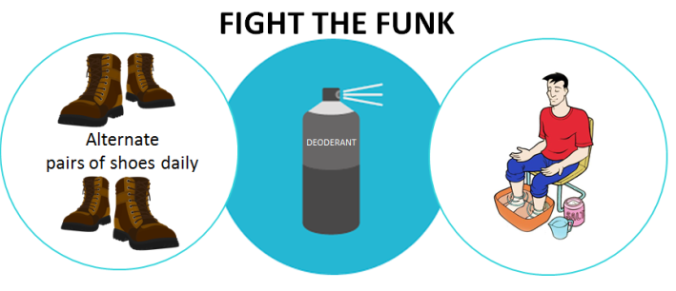
If the Shoe Fits… Help your feet feel their best! (And smell their best too!)

Diabetics Beware: A little TLC goes a long way in preventing foot problems from diabetes and checking your feet daily is the first step. Resolve foot sores and issues right away to prevent amputation.

Foot Woes & Foes: There are many types of foot issues; here are some of the most common ones.
Plantar Fasciitis - A heel injury, affecting the area where the arch meets the heel. It is marked by heel pain with first steps in the morning, possible swelling, and heel pain while walking. Usually it can be worked out with activity. What to do: Wear better shoes, or try orthopedic shoes prescribed by a podiatrist. Don't walk barefoot. Use ice unless you have circulatory problems or are diabetic. Try heel cups in your shoes for shock absorption. If the pain is persistent, see a podiatrist.
Heel Spurs - A little outgrowth of the bone, a result of the bone's attempt to heal after repetitive stress and inflammation in the plantar fascia. What to do: If it causes foot pain, a simple surgery to shave the spur away may be required.
Neuroma - A pinched nerve, causing pain between the third and fourth toes. It can feel like a tooth that needs a root canal. One of the most common causes is a poor shoe fit. What to do: Buy a shoe with a wider toe area.
Tendonitis - An inflammatory process in the tendons, common in athletes. It can be a serious, painful, and persistent problem. What to do: Rest, ice, use anti-inflammatory drugs, and change exercise technique and shoe gear.
Bunions - A misaligned big toe joint in which the toe slants outward causing inflammation and swelling. The most common cause is tight-fitting shoes. What to do: Wear proper-fitting shoes and padding, and rest and soak the foot. Bunions must be treated by a podiatrist
Hammertoe - When a toe, usually the second toe, bends up to look like a claw. It frequently accompanies a bunion, and while the actual cause is a muscle imbalance, the underlying cause of that imbalance is usually an ill-fitting shoe that cramps the toes. What to do: Wear proper-fitting shoes and padding. Hammertoes must be treated by a podiatrist
Corn - When there’s an area of pressure or a spot that’s especially bony on your foot, a corn can appear. Caused by the buildup of hard, dead skin, they are often cone-like and most commonly found on toe joints. Special skin cells found all over your outer layers of skin called keratinocytes produce this hard skin, which is your body's attempt at protecting itself from friction or pressure. Unfortunately, this extra skin can become an uncomfortable problem because the cone-shaped area transfers pressure to the skin underneath, causing discomfort. What to do: Wear properly fitting shoes and gently exfoliate the area until removed or visit a podiatrist for removal.
Nails Make a Big Difference in Comfort, Appearance, and Health
Ingrown toenail - This happens when the side of your toenail cuts into your skin. The cause is usually a bad toenail clip job, but pressure from a bad shoe fit can cause it, too. A mild ingrown nail can be removed with careful clipping, but if it is deep or painful, consider a trip to the podiatrist.
Black toenail - A hematoma (bruising) under the nail. What to do: Wear proper-fitting shoes that aren't too tight or too loose, clip toenails short so they won't rub against the shoe, soak foot in salt water.
Changes in the shape or texture of nails - Some nail changes, such as the formation of ridges, are normal with aging. Thick, brittle, or dark nails are more common in older adults who have poor circulation.
Separation from the nail bed - Once your nail separates from its nail bed, for whatever reason, it will not reattach. Nails grow back slowly. It takes about 6 months for fingernails and up to 18 months for toenails to grow back attached to the nail bed.
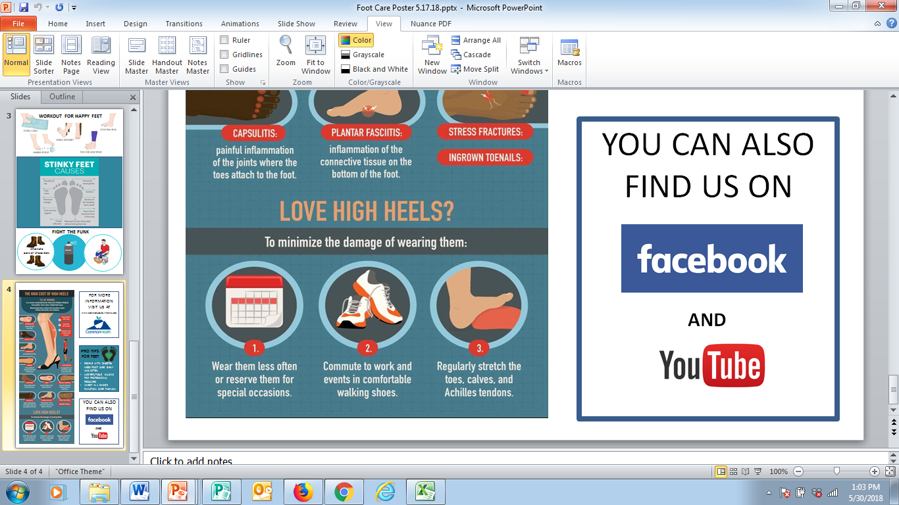
Infection and allergic reactions - These are common problems caused by artificial nails – be cautious with new products. Fungal nail infections, which can vary in appearance depending on the type of fungus infecting the nail or the location of the infection. It is not unusual for fungal nail infections to follow athlete's foot infections. Consult your doctor or podiatrist.
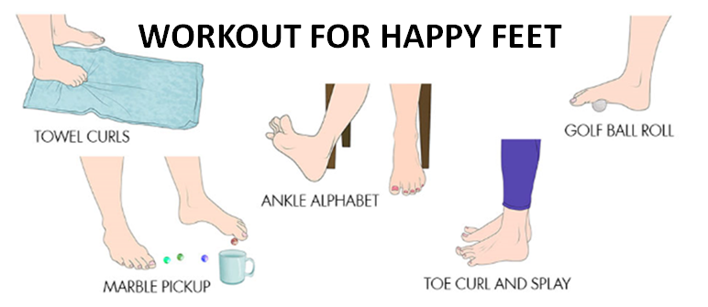
No Matter What You Wear…Try This!

Pedi Anyone? They are for EVERYONE!
1. SOAK – soak feet in a foot sized tub filled with warm water and ¼ cup Epsom salts for 10 minutes. That helps soften the skin to prep for exfoliation.
2. SCRUB – combine ½ cup kosher salt and ½ cup olive oil into a paste and gently scrub feet. The salt’s coarse grains remove dead skin cells and the olive oil moisturizes.
3. SOFTEN – slather honey all over feet. Let sit for 10 minutes. The honey helps lock in moisture to prevent cracked heels. Rinse your feet in the Epsom salts-water mix from step 1 and towel dry completely.

w
For more information, visit www.commonhealth.virginia.gov

